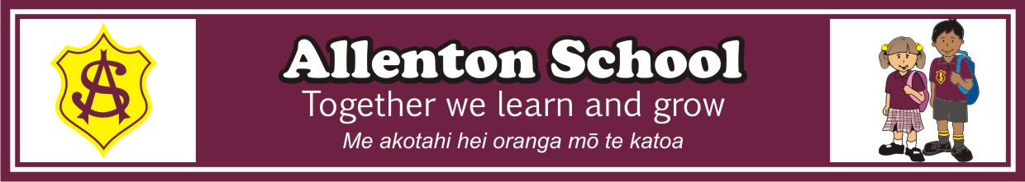
Middle Area Stationery 2020
Room 5,6,7,8,9
Years 3 and 4

The following are the stationery items your child will need to bring on day one, 2020. Please note the book number and purchase accordingly.
Exercise books will last longer and look better if they are covered. It is useful to have a different colour or label or picture on each book to give children a visual aid, helping them quickly tell the difference between their books in their desks.
Please name all items clearly! This includes all pencils, sharpeners etc. The children will write subject names on their books with their teacher at the beginning of the year.

Quantity | Type of Book
2 | Clever Kiwi Company “Fun Doing Maths 1” large books with green border
4 | 1I5 (9 mm ruled - please purchase one-eye-fives, not 1L5s)
1 | Clever Kiwi Company Reading Workbook
1 | Warwick Project Book (blank pages)
1 | 20 page clearfile
1 | Book or Journal Bag Medium 270 x 310mm (please use junior school book bag if suitable)

Other items needed:
* On the first day of school: 8 of the named pencils, 3 named biros and 1 of the named glue sticks to be handed to teacher for safe keeping until needed. *
- 1 Set of Headphones
- 10 HB pencils (good quality and named)
- 4 Blue Biros (named)
- Rubber
- Plastic or metal 30cm ruler (not flexible type)
- Pencil case
- 2 large glue sticks
- 2 Black Whiteboard Pens. We recommend Slimline medium tip or Sharpie Whiteboard fine as they last well and are a good size for children to manage.
- Coloured pencils or Jovi plastic crayons
- Pencil Sharpener
- 1 green highlighter
- Please supply one large box of tissues for school use. They will be stored at school in each classroom.
Optional
- Felts
- Teachers will check items such as rulers, pencils, rubbers at the end of each term and a note will be issued if an item needs to be replaced.

