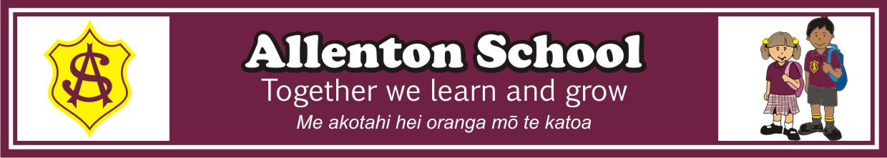
STATIONERY LIST 2021
Senior Year 5/6 classes ROOM 1, 2, 3, 4, 17

The following are the stationery items that your child will need to bring on the first day of school of 2021 to your conference with your teacher. Please note the number required of each book. Exercise books will last longer if they are covered. Please label each book with the subject underlined in the list.

PLEASE ENSURE THAT ALL ITEMS ARE CLEARLY NAMED

4 x 1B8 Writing
Handwriting
Reading
Wordstudy
1 x 1E8 Maths (preference is for the book with pre-ruled red lines)
2 x blank page scrapbook Maths
1 x lined scrapbook Topic
1 x blank page scrapbook Poetry / Art
4 x HB pencils (please ensure these are clearly named)
1 x rubber
1 x 30cm metric ruler - plastic (not the flexible type please)
3 x blue biro
2 x red biro
2 large gluestick
1 x 40 page clearfile (check out last year’s as it may be suitable)
1 x green highlighter
1 x pencil sharpener (not battery operated please)
1 x box of tissues (teachers will store these and distribute within the class)
1 x small pencil case
1 x headphones (please no bluetooth headphones) - these could be any suitable headphones from home
Choice of felts or Jovi crayons or coloured pencils (one set)

Families may wish to consider stocking up on high use stationery items such as pencils, pens and rubbers at the start of the year as stationery suppliers have specials on these. These could then be kept at home and the children bring them when they need them.

Optional:
Scissors

Teachers will check items such as rulers, pencils, pens and rubbers at the end of each term and a note will be sent home if an item has been lost/used and needs to be replaced. Paper Plus, Warehouse Stationery and OfficeMax are able to do the above package or just parts as needed. Order online or by phone and collect completed orders.

